

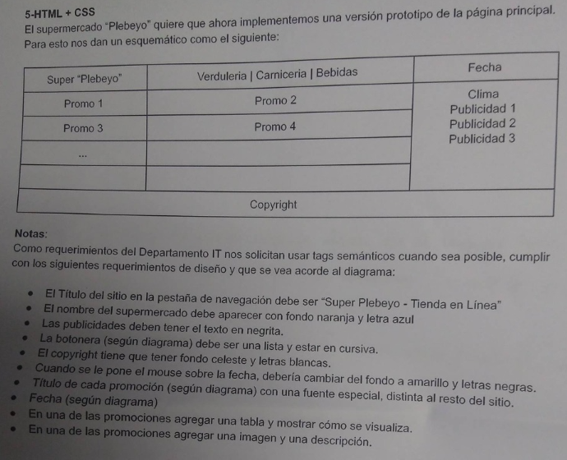

//falta uno escrito que es larguísimo y es del año del pedo

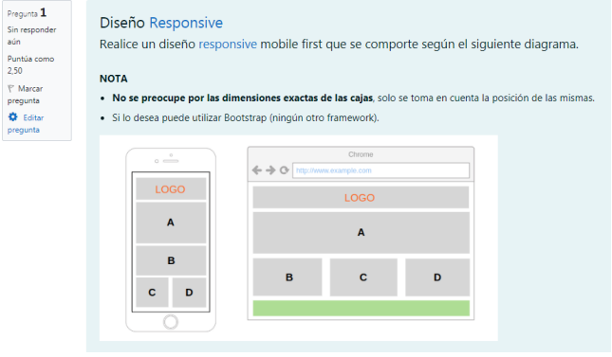

<!DOCTYPE html>

<html lang="en">

<head>

<meta charset="UTF-8">

<meta http-equiv="X-UA-Compatible" content="IE=edge">

<meta name="viewport" content="width=device-width, initial-scale=1.0">

<link rel="stylesheet" href="ejercicio.css">

<title>Document</title>

</head>

<body>

<header>

<h1>logo</h1>

</header>

<article id="a" class="bloque">

<p>A</p>

</article>

<section class="contenedor-3">

<section class="contenedor-1">

<article class="bloque">

<p>B</p>

</article>

</section>

<section class="contenedor-2">

<article id="espaciado" class="bloqueab">

<p>C</p>

</article>

<article class="bloqueab">

<p>D</p>

</article>

</section>

</section>

<footer></footer>

</body>

</html>

\* {

margin: 0;

padding: 0;

height: 100%;

font-size: 40px;

font-family: 'calibri', sans-serif;

text-transform: uppercase;

}

h1, .bloque, .bloqueab {

background-color: rgba(204, 200, 200, 0.918);

border: 1px solid black;

}

h1, p{

display: flex;

justify-content: center;

align-items: center;

}

header, .bloque, .bloqueab {

margin: 2%;

}

header {

height: 60px;

color: red;

}

.contenedor-3 {

height: 300px;

}

.contenedor-2 {

display: flex;

}

.contenedor-1 {

height: 200px;

}

.bloque{

height: 200px;

}

.bloqueab {

height: 130px;

width: 50%;

}

footer {

display: none;

}

@media only screen and (min-width: 400px) {

header, .bloque, .bloqueab, footer, #a {

margin: 1%;

}

header {

height: 80px;

}

.contenedor-3 {

display: flex;

}

.contenedor-2 {

width: 66%;

}

.contenedor-1 {

width: 34%;

}

.contenedor-2, .contenedor-1 {

padding: 1%;

}

#espaciado {

margin-right: 3%;

}

.bloque, .bloqueab, .contenedor-3 {

height: 220px;

}

.bloque, .bloqueab {

margin: 0%;

}

footer {

display: block;

background-color: green;

height: 10%;

}

}

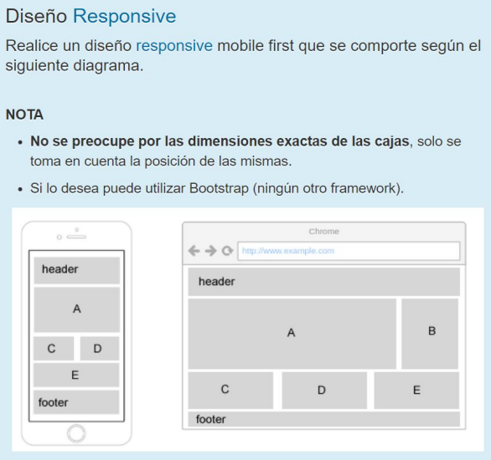

<!DOCTYPE html>

<html lang="en">

<head>

<meta charset="UTF-8">

<meta http-equiv="X-UA-Compatible" content="IE=edge">

<meta name="viewport" content="width=device-width, initial-scale=1.0">

<link rel="stylesheet" href="ejercicio11.css">

<title>Document</title>

</head>

<body>

<div class="contenedor">

<header>header</header>

<article class="arriba">

<section class="grande">A</section>

<aside>B</aside>

</article>

<article class="abajo">

<div class="subcontenedor">

<section class="mitad">C</section>

<section class="mitad">D</section>

</div>

<section>E</section>

</article>

<footer>footer</footer>

</div>

</body>

</html>

\* {

margin: 0;

padding: 0;

}

header, section, aside, footer {

border: 1px solid black;

width: 100%;

margin: 2px;

align-items: center;

}

header, section, footer, .subcontenedor {

display: flex;

}

header, footer{

padding: 3px;

}

section, aside{

justify-content: center;

}

.mitad {

width: 50%;

}

aside {

display: none;

}

@media only screen and (min-width: 400px) {

.arriba , .abajo, aside{

display: flex;

}

.subcontenedor {

width: 66%;

}

aside {

width: 40%;

}

.grande {

width: 60%;

}

section {

width: 33%;

}

}

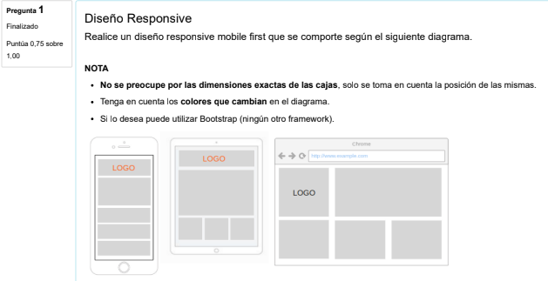

<!DOCTYPE html>

<html lang="en">

<head>

<meta charset="UTF-8">

<meta http-equiv="X-UA-Compatible" content="IE=edge">

<meta name="viewport" content="width=device-width, initial-scale=1.0">

<link rel="stylesheet" href="ejercicio12.css">

<title>Document</title>

</head>

<body>

<div class="contenedor">

<article class="contenedor-arriba">

<header>

<h1>logo</h1>

</header>

<div id="bloque"></div>

</article>

<article class="contenedor-abajo">

<section></section>

<section></section>

<section></section>

</article>

</div>

</body>

</html>

/\*celu\*/

\* {

margin: 0;

padding: 0;

height: 100%;

}

h1 {

display: flex;

justify-content: center;

align-items: center;

text-transform: uppercase;

color: red;

}

header {

height: 27%;

}

#bloque {

height: 70%;

}

.contenedor-arriba {

height: 40%;

}

section {

height: 33%;

}

.contenedor-abajo {

height: 60%;

}

header, #bloque, .contenedor-arriba, section, .contenedor-abajo {

width: 100%;

}

header, #bloque, section {

border: 1px solid black;

background-color: grey;

margin: 2px;

}

/\*tablet\*/

@media only screen and (min-width: 400px) {

#bloque {

height: 70%;

}

.contenedor-arriba {

height: 70%;

}

section {

height: 100%;

width: 33%;

}

.contenedor-abajo {

height: 30%;

display: flex;

}

}

/\*compu\*/

@media only screen and (min-width: 1000px) {

\* {

margin: 0;

padding: 0;

height: 100%;

}

h1 {

color: black;

}

header, #bloque {

height: 98%;

}

.contenedor-arriba {

display: flex;

height: 50%;

}

section {

height: 100%;

width: 33%;

}

.contenedor-abajo {

height: 50%;

}

.contenedor-arriba, .contenedor-abajo {

width: 100%;

}

}

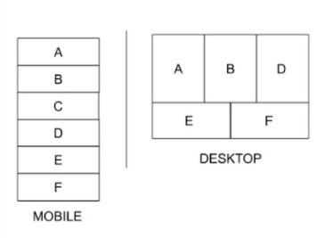

<!DOCTYPE html>

<html lang="en">

<head>

<meta charset="UTF-8">

<meta http-equiv="X-UA-Compatible" content="IE=edge">

<meta name="viewport" content="width=device-width, initial-scale=1.0">

<link rel="stylesheet" href="ejercicio10.css">

<title>Document</title>

</head>

<body>

<div class="contenedor">

<article class="arriba">

<section>

<p>A</p>

</section>

<section>

<p>B</p>

</section>

<section id="ocultar">

<p>C</p>

</section>

<section>

<p>D</p>

</section>

</article>

<article class="abajo">

<section>

<p>E</p>

</section>

<section>

<p>F</p>

</section>

</article>

</div>

</body>

</html>

\* {

margin: 0;

padding: 0;

}

section {

border: 1px solid black;

display: flex;

justify-content: center;

align-items: center;

}

.contenedor {

height: 100%;

}

section, .contenedor {

width: 100%;

}

@media only screen and (min-width: 400px) {

#ocultar {

display: none;

}

.arriba {

height: 60%;

}

.abajo {

height: 40%;

}

.arriba, .abajo {

display: flex;

}

}

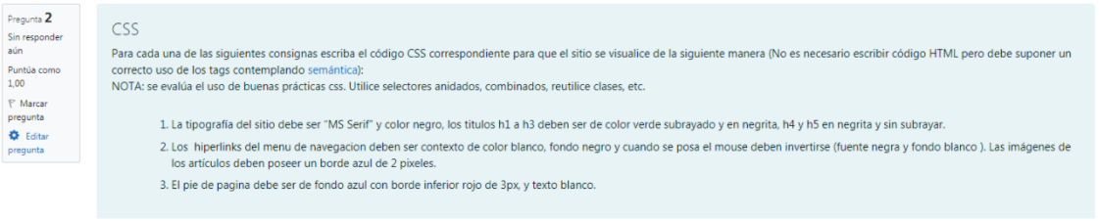

/\* 1 \*/

\* {

font-family: 'MS-Serif';

color: black;

}

h1, h2, h3 {

color: green;

text-decoration: underline;

}

h1, h2, h3, h4, h5 {

font-weight: bold;

}

/\* 2 \*/

/\* no aclara nada del subrayado (para sacarlo text-decoration: none)

y no aclara nada de las viñetas (para sacarlas list-style-type: none)\*/

ul li a { //o nav a

color: white;

background-color: black;

}

ul li a:hover {

color:black;

background-color: white;

}

/\*las img de qué articulos? de la nav bar o de <article>s? \*/

article img {

border: 2px solid blue

}

/\* 3 \*/

footer {

background-color: blue;

border-bottom: 3px solid red;

color: white;

}

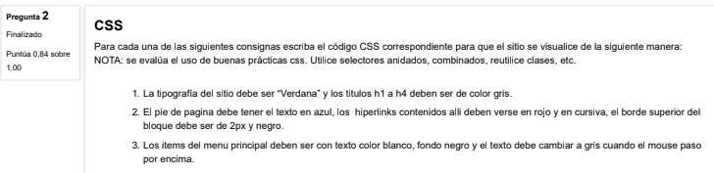

/\* 1 \*/

\* {

font-family: "Verdana";

}

h1, h2, h3, h4 {

color: grey;

}

/\* 2 \*/

footer {

color: blue;

border-top: 2px solid black;

}

footer a {

color: red;

font-style: italic;

}

/\* 3 \*/

ul li a {

color: white;

background-color: black;

}

ul li a:hover {

color: grey;

}

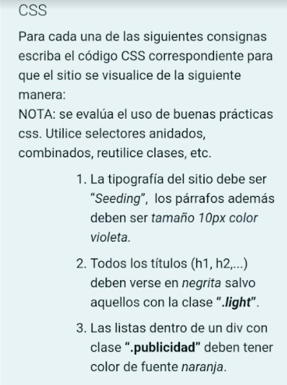

/\* 1 \*/

\* {

font-family: "Seeding";

}

p {

font-size: 10px;

color: purple;

}

/\* 2 \*/

h1.light, h2.light, h3.light, h4.light, h5.light, h6.light {

font-weight: normal;

color: red;

}

/\* 3 \*/

.publicidad ul li { /\*o sin el li\*/

color: orange;

}

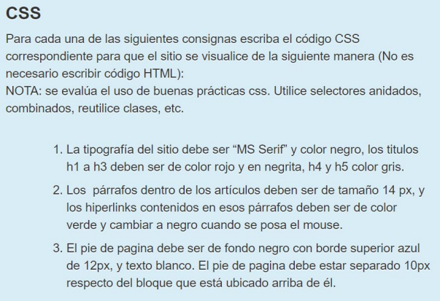

/\* 1 \*/

\* {

font-family: "MS Serif";

color: black;

}

h1, h2, h3 {

color: red;

font-weight: bold;

}

h4, h5 {

color: grey;

}

/\* 2 \*/

article p {

font-size: 14px;

}

article p a {

color: green;

}

article p a:hover {

color: black;

}

/\* 3 \*/

footer {

background-color: black;

border-top: 12px solid blue;

color: white;

margin-top: 10px;

}